

**Group members:**

Ishma Hafeez K21-4688

Umer Naeem K21-4927

Bilal Abdul 21K-4522

Course: Digital Logic Design (2022 spring)

Course code: EE227

Assignment: Project

**HEAT SENSOR CIRCUIT**

**Problem statement**:

To design and implement a circuit, which notifies the user through an led when hear is sensed through a thermistor.

**Methodology:**

This Circuit was build using Arduino Uno 3 with LM35 Heat sensor connected using jumper wires. The Arduino Compiler Code confirms in the Output pins of the Heat sensor and Runs the code in loop where temperature is being calculated using a formula to convert voltage into temperature.

**Project Picture:**

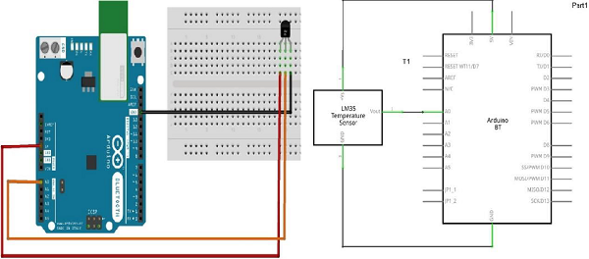

**Conclusion:**

1. This Heat sensor can sense and display temperature on serial monitor of the IDE Compiler of Arduino.
2. In future we will increase the radius of the heat sensor.

CODE

